1. 
2. 
3. 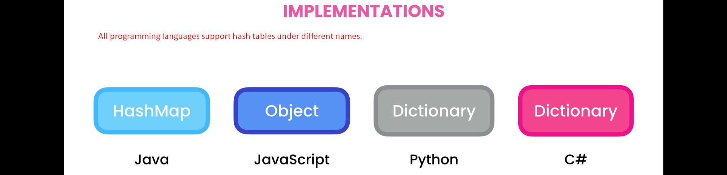
4. 
5. 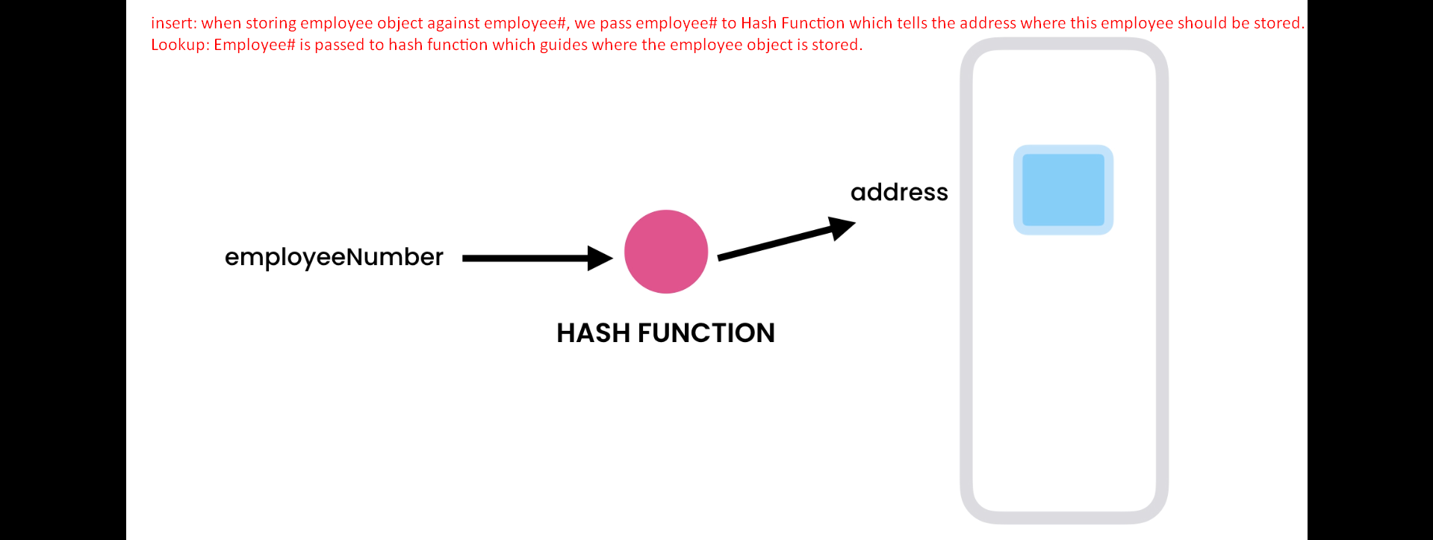 
6. Internally hash table uses array to store an objects.
7. 